**Activity: Species Richness**

**Species richness** is the number of species in an area. For example, if an area contains humpback whales, blue whales, and bottlenose dolphins, the species richness of that location is three. In this activity you will determine the number of species in your classroom by creating a **rarefaction curve**, a graph of the total number of species found versus the amount of time spent searching for species.

**Materials**

* Species cards
* Timer
* Two pens or pencils of different colors

**Procedure**

1. Imagine that your class is going on a field trip to do a survey of a habitat area. This area has been extremely well studied. Scientists estimate that there are 500 different species at the site. Some of these species are large, abundant, and obvious. However, most of the species are small, hidden, or rare. Answer the following questions:
   1. Your class goes to the study site to do a field survey, but you get a late start and only have half an hour at the site. Do you think your class can find all 500 species in 30 minutes?
   2. Your class returns to the same field site on a different day. This time your class has one hour to search the site. How do you think your list of species compiled on this day–searching for one hour–will compare with the first day when you only had 30 minutes?
   3. Your class returns a third time to the field site. This time your class has two hours at the site. How do you think your species list for the two hour survey will compare to the lists generated the first two field trips?
2. Make a prediction about the amount of time spent searching and the number of species that will be found. Graph your prediction in Figure 1.

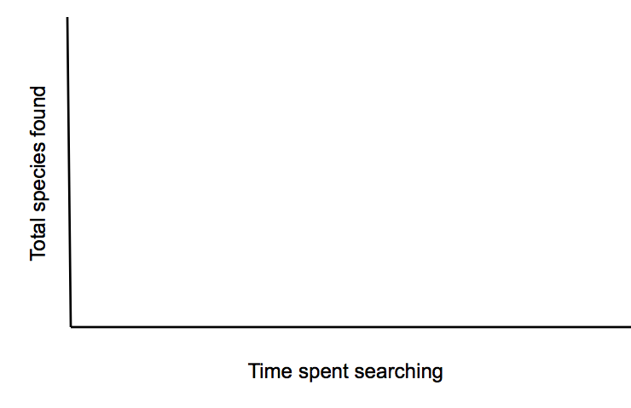

**Figure 1**. Prediction of the number of species that will be found over time

1. You will test your prediction using a card model. The classroom will represent the habitat study site, and the cards will represent the species in the habitat area. Some members of the class (the searchers) will leave the room. While they are gone, other members of the class (the hiders) will hide species cards around the room. Here are some tips for hiding the species cards:
   1. Some of the places in your classroom are unsafe and will be prohibited by your teacher. Have your teacher share any hiding and searching rules, or develop a safe hiding/searching procedure as a class.
   2. The most basic rule in searching for species in the field, and classroom, is not to destroy the habitat. For example, if you roll a rock over to look underneath it, you must put it back exactly the way it was. In the classroom, if you lift up an object to look underneath it, you must put it back.
   3. The searchers should leave the room. The remaining members of the class (the hiders) should hide species cards around the room according to the classroom hiding rules. *This step may have already been done by your teacher.*
2. The searchers can come back in the room when all of the species cards are hidden. Searchers are allowed to search the classroom for 30 seconds. Do not help the searchers find species cards! In nature you would not know where species are located; by not helping the searchers this model is more realistic.
3. At the end of 30 seconds, record the number of species found, the number of new species found, and the total (cumulative) number of species found in the area over time. (Table 1).
4. Repeat 30-second search intervals at least five more times. Fill in Table 1.
5. *Optional*. Continue your search for an additional two intervals if you feel you can find more species in the classroom.

**Table 1**: Number of card species hidden in the classroom

|  |  |  |  |  |
| --- | --- | --- | --- | --- |
| **Interval** | **Cumulative**  **Time (seconds)** | **Number of**  **Species found** | **Number of**  ***New* species found** | **Total**  **(cumulative) number of**  **species found** |
| 0 | 0 |  |  |  |
| 1 | 30 |  |  |  |
| 2 | 60 |  |  |  |
| 3 | 90 |  |  |  |
| 4 | 120 |  |  |  |
| 5 | 150 |  |  |  |
| 6 | 180 |  |  |  |
| 7  *(optional)* | 210 |  |  |  |
| 8  *(optional)* | 240 |  |  |  |

1. Make a line graph of the total species found against the amount of time spent searching (Fig. 2). This is called a **rarefaction curve**.

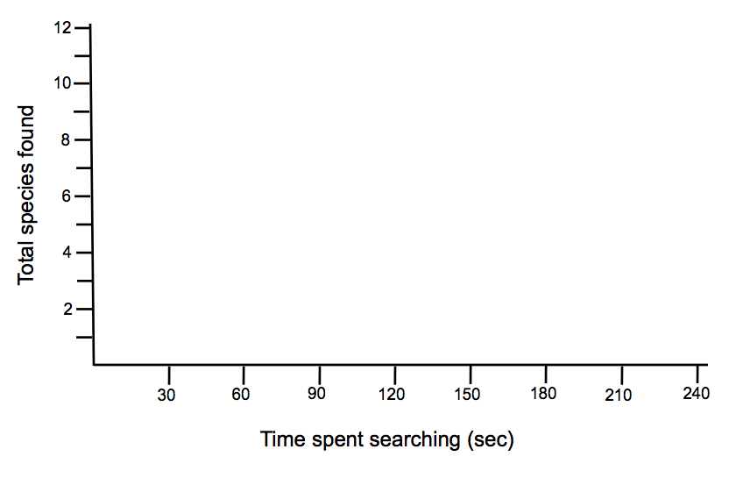

**Figure 2**. Classroom rarefaction curve

**Rarefaction Curves**

Scientists examine the shape of rarefaction curves to determine when a species search can reasonably be terminated. Although there may still be species left to be found, when the curve flattens out, the majority have probably been discovered and the relationship between additional time spent searching and number of new species found is likely to be minimal.

1. Label, with a star, the point on your rarefaction curve where you would call off a search because the rarefaction curve has flattened out. At this point you are assuming that:
   1. The majority of species in an area had been found
   2. If the cards were hidden again in a similar way, and if similar students searched the area again, the search could be stopped at a similar time and a similar number of species would have been found.
2. Replicate the game at least one more time with different searchers and hiders. Record your results in Table 1 and Figure 2 using a different colored pen or pencil.

**Activity Questions**

1. How can you know if you found all the species in a given area?

2. Why are some species harder to find? Did you find all of the species cards in the classroom? Why or why not?

3. What would happen if the searchers got help from the hiders? How would this affect the shape of the rarefaction curve?

4. How did your results compare with your prediction?

5. One of your friends has been searching for species in the same area for one hour every day for 17 days and has graphed the rarefaction curve shown in Figure 3. You are going to search for species in the same area as your friend using the same search technique, one hour a day every day. Looking at Fig. 3, what is the fewest number of days you can search and find almost all of the species in the area?

**Figure 3**: Rarefaction curve showing total number of species found over the span over approximately 16 days of sampling in the field.

6. How similar or different were your classroom results, in terms of number of species found and the shape of your rarefaction curve, when you repeated the game?

7. What would happen if two different areas were searched for different amounts of time, or with different numbers of people? Could the results be compared?

8. How can you modify your data so comparisons can be made between areas searched for different amounts of time or with different numbers of people?

9. What are the limitations of a list of species? (Hint: think about how you would count the number of species when it is difficult to determine what an individual organism is, for example, sponges or some algal species.)

**Activity: Species Richness Teacher Text**

**Species richness** is the number of species in an area. For example if an area contains humpback whales, blue whales, and bottlenose dolphins, the species richness of that location is three. In this activity you will determine the number of species in your classroom by creating a **rarefaction curve**, a graph of the total number of species found versus the amount of time spent searching for species.

*This activity helps prepare students to make a general search of an area, focusing on sampling effort and standardizing techniques.*

**Materials**

* Species cards
* Timer
* Two pens or pencils of different colors

*To represent different species, use index cards or pictures cards of organisms with the scientific name of the species (you may also choose to include the common name(s) of the species). Use species your class is familiar with or species from a field site the class has been to or will be studying.*

*This activity works well with 50 cards representing twelve species of varying rarity. Table 1 has examples of species to use from the Hawaiian intertidal ecosystem. The card abundances are similar to the representative species abundances in the field. For example, it would be rare to find an Octopus cyanea (Day octopus, he’e mauli) in the intertidal, but Littoraria pintado (Dotted periwinkle, pipipi kolea) are very common. If you change the number of species, you will have to increase the Y-axis in Figure 2.*

***Table 1:*** *Suggested proportion of example species from Hawaiian intertidal ecosystem*

|  |  |  |  |
| --- | --- | --- | --- |
| **Number of species** | **Number of individuals per species** | **Examples of Species from the Hawaiian Intertidal** | **Number of Cards** |
| 3 | 1 | *Octopus cyanea*, Day octopus, he’e mauli  *Stenopus hispidus*, Banded coral shrimp  *Aplysia juliana*, Juliana’s sea hare, kualakai | 3 |
| 3 | 2 | *Conus lividus*, Spiteful cone snail  *Echinometra mathaei*, Rock-boring urchin, ‘ina kea  *Actinopyga mauritiana,* White-spotted sea cucumber, loli  *Cypraea caputophidii,* Snakehead cowry, leho kupa,  leho ku‘e lima | 6 |
| 2 | 3 | *Calcinus laevimanus*, Left-Handed hermit crab  *Onchidium verruculatum*, Warty slug | 6 |
| 2 | 5 | *Morula uva*, Grape morula  *Siphonaria normalis*, False opihi, ‘opihi-‘awa  *Ophiocoma erinaceus*, Spiny brittle star | 10 |
| 1 | 10 | *Nerita picea,* Black nerite, pipipi | 10 |
| 1 | 15 | *Littoraria pintado,* Dotted periwinkle, pipipi kolea | 15 |
| **12** |  | | **50** |

**Procedure**

1. Imagine that your class is going on a field trip to do a survey of a habitat area. This area has been extremely well studied. Scientists estimate that there are 500 different species at the site. Some of these species are large, abundant, and obvious. However, most of the species are small, hidden, or rare. Answer the following questions:
   1. Your class goes to the study site to do a field survey, but you get a late start and only have half an hour at the site. Do you think your class can find all 500 species in 30 minutes?
   2. Your class returns to the same field site on a different day. This time your class has one hour to search the site. How do you think your list of species compiled on this day (searching for one hour) will compare with the first day (when you only had 30 minutes)?
   3. Your class returns a third time to the field site. This time your class has two hours at the site. How do you think your species list for the two hour survey (120 minutes) will compare to the lists generated the first two field trips?

*Students will probably agree that not all species can be found on any of these field trips, but that given more time at the site more species will be found.*

1. Make a prediction about the amount of time spent searching and the number of species that will be found. Graph your prediction in Figure 1.

*Answers will vary. Most students’ graphs will probably show that over time, the number of new species found will decrease, and that the number of total species found will level out. If students’ graphs show that the relationship between the time spent looking for species and the number of species found is positively correlated, ask if they think this relationship is indefinite.*



**Figure 1**. Prediction of the number of species that will be found over time

1. You will test your prediction using a card model. The classroom will represent the habitat study site, and the cards will represent the species in the habitat area. Some members of the class (the searchers) will leave the room. While they are gone, other members of the class (the hiders) will hide species cards around the room. Here are some tips for hiding the species cards:
   1. Some of the places in your classroom are unsafe and will be prohibited by your teacher. Have your teacher share any hiding and searching rules, or develop a safe hiding/searching procedure as a class.
   2. The most basic rule in searching for species in the field, and classroom, is not to destroy the habitat. For example, if you roll a rock over to look underneath it, you must put it back exactly the way it was. In the classroom, if you lift up an object to look underneath it, you must put it back.
   3. The searchers should leave the room. The remaining members of the class (the hiders) should hide species cards around the room according to the classroom hiding rules. *This step may have already been done by your teacher.*

*It is useful to have “hiding/searching rules” in place, to keep the search safe and as tidy as possible. In the interest of time, you can pre-hide the cards around the room. If you hide the cards, you can choose to hide some in more obvious places and some in more difficult places. If your students hide the cards, they will probably all be in difficult places! If students will hide the cards, pass out cards to the “hiders”. This may be most of your class or just a small group. Less or more students can leave the room depending on class size.*

1. The searchers can come back in the room when all of the species cards are hidden. Searchers are allowed to search the classroom for 30 seconds. Do not help the searchers find species cards! In nature you would not know where species are located; by not helping the searchers this model is more realistic!

*You may have to adjust the time interval depending on how well cards are hidden and how quickly students find the cards. If cards are hidden particularly well, you may have to increase the interval to one minute. You can then use the additional optional intervals if your students have not found a number of species cards. On the other hand, if your students find all the cards in just a couple of intervals, you should decrease your intervals to 15 seconds to graph a more realistic rarefaction curve.*

1. At the end of 30 seconds, record the number of species found, the number of new species found, and the total (cumulative) number of species found in the area over time. (Table 1).
2. Repeat 30-second search intervals at least five more times. Fill in Table 1.

*If you do not return the cards to the same or new hiding places, this is called sampling without replacement. If you choose to modify this activity to incorporate re-hiding of cards, it would be sampling with replacement.*

1. *Optional*. Continue your search for an additional two intervals if you feel you can find more species in the classroom.

**Table 1**: Number of card species hidden in the classroom

|  |  |  |  |  |
| --- | --- | --- | --- | --- |
| **Interval** | **Cumulative**  **Time (seconds)** | **Number of**  **Species found** | **Number of**  ***New* species found** | **Total**  **(cumulative) number of**  **species found** |
| 0 | 0 | *0* | *0* | *0* |
| 1 | 30 | *4* | *4* | *4* |
| 2 | 60 | *6* | *3* | *7* |
| 3 | 90 | *5* | *1* | *8* |
| 4 | 120 | *5* | *2* | *10* |
| 5 | 150 | *4* | *1* | *11* |
| 6 | 180 | *3* | *0* | *11* |
| 7  *(optional)* | 210 | *2* | *0* | *11* |
| 8  *(optional)* | 240 | *3* | *1* | *12* |

*Over time the number of new species found deceases even though cards of all species are still being captured.*

1. Make a line graph of the total species found against the amount of time spent searching (Fig. 2). This is called a **rarefaction curve**.

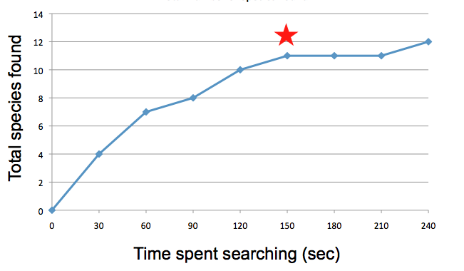

**Figure 2**. Classroom rarefaction curve

**Rarefaction Curves**

Scientists examine the shape of rarefaction curves to determine when a species search can reasonably be terminated. Although there may still be species left to be found, when the curve flattens out, the majority have probably been discovered and the relationship between additional time spent searching and number of new species found is likely to be minimal.

1. Label, with a star, the point on your rarefaction curve where you would call off a search because the rarefaction curve has flattened out. At this point you are assuming that:
   1. The majority of species in an area had been found
   2. If the cards were hidden again in a similar way, and if similar students searched the area again, the search could be stopped at a similar time and a similar number of species would have been found.

*In our example this would be at ~150 seconds.*

1. Replicate the game at least one more time with different searchers and hiders. Record your results in Table 1 and Figure 2 using a different colored pen or pencil.

**Activity Questions**

1. How can you know if you found all the species in a given area?

*You may never know completely, especially for rare or very cryptic things. One thing scientists do is look at a rarefaction curve. They look at the number of total species found over time. When the curve starts to level off, the assumption is that most species have been found.*

2. Why are some species harder to find? Did you find all of the species cards in the classroom? Why or why not?

*Some species may be better at hiding (or in the case of the cards, hidden by a student who is really good at hiding them), or are very rare. When you are out in the field looking for actual organisms, some may be very fast, and others may only come out at night.*

3. What would happen if the searchers got help from the hiders? How would this affect the shape of the rarefaction curve?

*Not only is this unrealistic, in the field you will not be omnipotent (all knowing) and be able to locate all the species. Helping the searchers also affects the results by changing the shape of the rarefaction curve. The rarefaction curve would have a steeper slope in the beginning, and flatten out at the maximum number of species more quickly.*

4. How did your results compare with your prediction?

*Answers will vary based on student results.*

5. One of your friends has been searching for species in the same area for one hour every day for 17 days and has graphed the rarefaction curve shown in Figure 3. You are going to search for species in the same area as your friend using the same search technique, one hour a day every day. Looking at Fig. 3, what is the fewest number of days you can search and find almost all of the species in the area?

**Figure 3**: Rarefaction curve showing total number of species found over the span over approximately 16 days of sampling in the field.

*About 10 days. While new species are still found past this date, there is limited returns on search effort.*

6. How similar or different were your classroom results (in terms of number of species found and the shape of your rarefaction curve) when you repeated the game?

*Answers will vary based on student results, but should be similar if species card were*

*hidden in a similar fashion.*

7. What would happen if two different areas were searched for different amounts of time, or with different numbers of people? Could the results be compared?

*We could not make a straight comparison. This question gets at the idea of standardization–that things should be as similar as possible in a study to make comparisons easy and appropriate. When planning a study, scientists should standardize as many things as possible (e.g. time, people, area, search techniques).*

8. How can you modify your data so comparisons can be made between areas searched for different amounts of time or with different numbers of people?

*To standardize field studies, you could divide the total number of species found by the number of people searching or the amount of time spent searching to get a catch per unit effort (CPUE). See optional variations–effect of number of people searching and effect of search area.*

9. What are the limitations of a list of species? (Hint: think about how you would count the number of species when it is difficult to determine what an individual organism is, for example, sponges or some algal species.)

*We could count and identify all of the species - but what if there is a lot of one species in one area and not another? How could these sites be compared? What is the meaning of one sponge? Is one tiny sponge the same as one huge sponge? Species richness does not tell anything about the relative abundance of different species. Scientists use different sampling tools to determine abundance.*

***Optional Variations***

**Safety Hazards:**

The longer scientists search in for species in the field, the more likely someone is to get hurt, even if they are careful. You can simulate this safety hazard in our model by adding two more cards to the deck of card species. For example, in our intertidal ecosystem this can be a “bitten by moray eel” and a “stung by cone snail” card. These cards should be hidden like the rest of the species, but when searching the area the student(s) who find these cards have to immediately stop searching and “go to the emergency room” (e.g. sit back down in their seats). Although species in many environments can often be safely surveyed, in the intertidal moray eels and cone snails are two potentially hazardous species students have to be aware of in the field.

**Effect of Number of People Searching:**

To examine the impact of the number of people searching, have seven students leave the room and allow others to hide cards. Have one student come back in and search for 30-second or one-minute intervals for five or six trials. Record how many species they find and then re-hide those cards (in the original places if possible). Then have two students enter and search for the same time interval for the same number of trials. Record and re-hide. Have the last four students enter the room and search for the same time interval and number of trials. By making sure all the time intervals are the same, the only change is in effort is due to the number of searchers, rather than by time spent searching. Students can graph the number of species found versus the amount of time spent searching by different numbers of people. Adding more searchers is similar to replicating in earlier experiments, the more replication you have the more accurate your results can be as you account for variation in searcher behavior.

**Effect of Search Area:**

To simulate the effect of searching over different sized areas, vary the space in which students can search. One team of four can be restricted to an area 1/4 the size of the room, and a second team can search the other 3/4 of the room. Keep intervals and number of trials the same for each team. You can also restrict where people search (i.e., no bookshelves) to get at the effects of ignoring some types of habitats. You should not let the students know which areas will be restricted until after the cards are hidden, so species may – or may not – be in the restricted areas.

**Effect of Number of People Searching and Search Area – Mathematical extension**

Activity question #7 gets at the idea of how to standardize data even if the conditions under which the data were recorded vary. One way to standardize data is to use catch per unit effort (CPUE). This is a common way to represent data collected from a variety of sources in many different situations, such as in fisheries, where many different types of boats using different types of gear are catching the same species of fish. Some typical measures of CPUE used in fisheries are hook or net hours (number of fish captured divided by total time all hooks or nets on a boat spent in the water) or boat hours (number of fish captured divided by time spent fishing).

You can calculate CPUE to control for the number of people searching and the size of the search area by dividing the total number of species found by time and/or by the number of people using the following equation:

= __________Total number of species found_________

(Number of people searching) x (Search area)

This CPUE equation can also be used for a single species, in which case the numerator would be “total number found or caught” of your species of interest.

**Effect of Species Distribution:**

This activity assumes that the species cards are hidden randomly around the room. However, many species are not evenly spaced in the field. For example, in the intertidal some species cluster in the high intertidal while others cluster in the low intertidal, creating different ecological zones that lie in bands along the coast. This can be simulated in the classroom by clumping cards of the same species. This can be done with structures, e.g. hiding all the Littoraria pintado cards on bookcases, or in bands, e.g. hiding all the Nerita picea cards at the front of the room or all the Morula uva cards very low to the ground. If your students are hiding the cards, you will need to instruct them on how to most accurately replicate the hiding of real life organisms.