**Sampling for Abundance**

A **transect** is a line of known length, marked at regular intervals. Transects are used for sampling in the field. The length of a transect, and the distance between measurement intervals, is dependent on what is being studied. A transect line can be a physical item that is purchased commercially (Fig. 1 A and B) or a line that is made by marking regular intervals on a piece of rope (Fig. 1 C). A transect line can also be an invisible line between two points. For example, ships can sample along an invisible transect line across the ocean using maps and GPS.

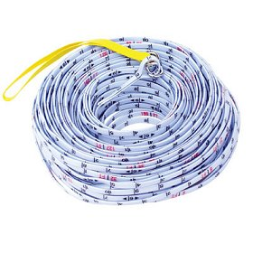

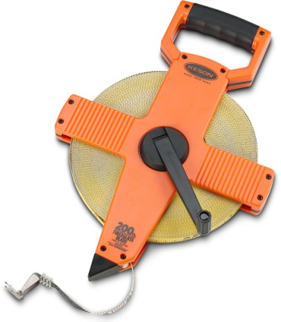

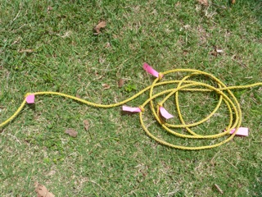

<http://www.forestry-suppliers.com/Images/Large/5653_40023_p1.jpg>

<http://www.bapequipmentstore.com/index.php?l=product_detail&p=933>

Image courtesy of A. Gundersen

**Figure 1.** Different types of transect lines: (A) Open-reel measuring tape transect, (B) Surveyor’s rope transect, and (C) Rope with regularly marked intervals

A **quadrat** is a framed area of known size and dimension. Physically, quadrats are generally square and often constructed with string that divides the area into a set number of squares. A quadrat frame can be made using PVC pipes, wire hangers bent into squares, wooden dowels, cardboard, or even a hula-hoop (for a round quadrat). String or monofilament fishing line can be used to divide the quadrat into a grid (Fig. 2).

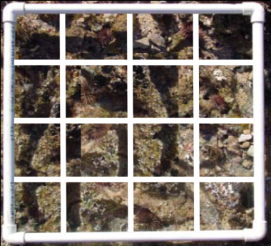

Image courtesy of J. Philippoff

**Figure 2.** Quadrat in field with lines clearly marked. This quadrat has six intersecting lines of string that divide the quadrat into 16 squares and create nine intercepts. Quadrats can have more or less intercepts and squares depending on the number of string lines.

Much like transects, different sized quadrats are used for different types of sampling. The size of a quadrat is dependent on the size of the area that scientists want to sample. Quadrats can be used in conjunction with transects or quadrats can be used on their own to aid in sampling an area.

The purpose of a **survey** is to examine and describe some aspect of an area or environment. Transects and quadrats are two sampling tools that can be used to randomly or systematicallysurvey an area. Both random and systematic sampling strategies are valid ways to characterize an environment; the choice of sampling strategy is dependent on the survey goal.

Random sampling can involve techniques such as taking measurements at random coordinates on a map or at random points along a transect line. Choosing random numbers can be as simple as picking numbers out of a hat, but sometimes scientists use computer software to make generating random numbers easier. Systematic sampling is regular. Systematic sampling generally involves focusing on transect points a set distance apart and taking measurements along a transect at pre-chosen points or regular intervals.

Practices of Science: **Census vs. Survey**

The purpose of a **census** is to collect information about every single item you are interested in studying in an area. For example, if a scientist were interested in the size of intertidal snails along a coastline and wanted to use the census method of surveying, the scientist would measure the size of *every single snail* along that coastline.

Although collecting information about every individual is useful, taking census data is often logistically impossible due to time and cost constraints. Because scientists know they will likely miss individuals if they try to collect census data, they usually **survey** an area using samples of the population they are interested in studying instead. To survey an area, scientists examine and describe some aspect of an area or environment. Survey samples can be examined to estimate and infer characteristics about the entire population. There are many different ways of performing surveys and many different forms of sampling techniques that can be used to collect data depending on the discipline of the researcher (e.g. geology, geography, psychology) and the goals of the study. Instead of a census, the scientist interested in snail size might survey snail sizes by measuring snails from sample intertidal sites and use this data to infer something about the size of all of the snails along the coastline. In a survey, scientists can also design their protocols to ensure that rare, small, or hidden organisms (or areas) are included.

**The US Census:** Despite the difficulties involved in a census, every ten years the United States Census Bureau tries to collect information from every resident in United States. This information is used to allocate federal funding, congressional seats, and electoral votes.

With the U.S. population totaling over 308 million in 2010, collecting census information is a daunting task. Although tremendous resources are allocated for the US census, a small percentage of people are inevitably missed. It is impossible to know exactly who is missing from the census, but researchers know from comparison studies that some segments of the population are easier to count in the census than others.

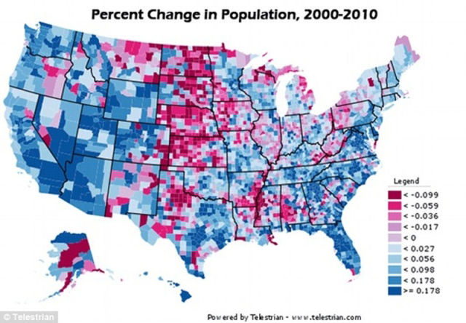

<http://img.izismile.com/img/img4/20110401/640/fascinating_us_census_640_07.jpg>

**SF Fig. 1.** This figure, generated from US Census data collected in 2010, shows the percent change in the US population between 2000 and 2010. The dark blue areas show population increases indicating people are moving into these areas of the country. The dark red areas show population decreases indicating people are moving out of these areas.

**Special Feature Questions:**

1. What segments of the population might be missed in the US census? Why?
2. How might surveying a population by collecting many samples provide more useful information than a census, especially if there are not a lot of resources available to do the study?
3. What might be some benefits of conducting a census even if you miss some segments of the population?

**Sampling Methodologies**

Three common systematic sampling methods using transects and quadrats will be demonstrated by surveying a mock study site (Fig. 3). The different colored circles can represent any variable of interest in an area, such as rocks, water chemistry, or plant growth.

At this mock study site, the colored circles represent different species of organisms. The empty white area represents the **substrate**, which is the substance on the bottom of the environment. Examples of different substrates include mud, pebbles, and boulders. In this example, the white area represents sand. In this case, the environment is also the **habitat** where the colored circle species live. This is a **benthic** survey because the circles represent organisms that live close to, or attached to, the substrate.

**Transects_Circles1.tif**

**Figure 3.** A mock study site where different organisms are represented by different circles. Different colors represent different species of organisms.

Notice how the circle species in Figure 3 appear to occur in zones from left to right. The blue circles are grouped on the left; the red circles are located on the right. Green and yellow circles, on the other hand, are located throughout the study site. **Ecological zonation** is the distribution of organisms into bands based on differences in biotic and abiotic factors. To capture this zonation, a transect, represented in Figure 4 by a black line, is laid perpendicularly through the zones (Fig. 4).

**Transects_Circles2.tif**

**Figure 4.** The black line represents a transect line. White circles mark numbered points at regular intervals along the transect.

One of the simplest ecological sampling methods is transect point-intercept. In the **transect point-intercept** method, a transect is laid in an environment and scientists record what is directly under the transect at certain points. The sampling points are often at regularly spaced intervals, such as each meter or half meter, along the transect line (Table 1). In this mock study site, transect points are in meters. When using the point-intercept method, it is important to record only the organisms or substrate that is directly beneath the transect line. For example, even though a red circle is very close to transect point #5, only “sand” is recorded on the data sheet (see Table 1).

**Table 1.** Data sheet for mock study site using the transect point-intercept method

|  |  |
| --- | --- |
| **Transect Point (m)** | **Organism/Substrate** |
| 1 | Blue |
| 2 | Blue |
| 3 | Sand |
| 4 | Yellow |
| 5 | Sand |

The transect point-intercept technique is good for sampling a large area relatively quickly, but this method can miss information in complex areas. In the mock study site (Fig. 4), we only recorded two of the four species in the area. Sometimes placing more than one transect in a study site, or using quadrats, can help to further document and characterize the complexity of an area (Fig. 5).

**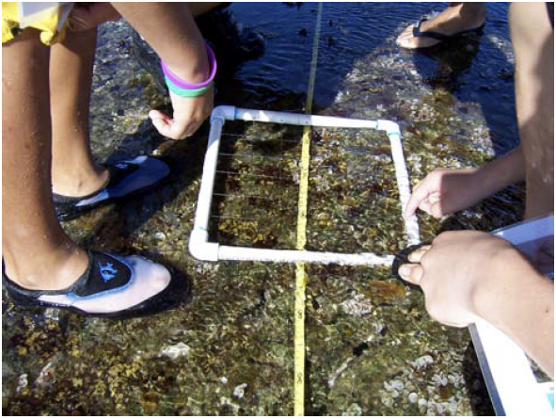 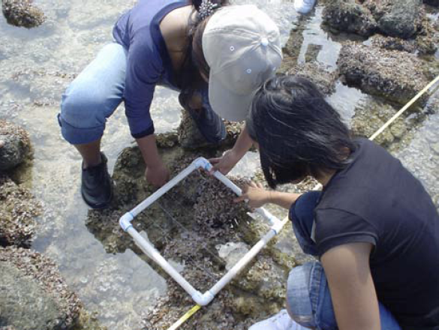**

Photos by J. Philippoff

**Figure 5.** Quadrats can be placed right over the transect point (A) or at the corner of the transect point (B). The quadrats in these diagrams have intercepting lines, but because the lines are fishing line and the quadrats are in the water they are hard to see in these photographs.

Quadrats are often placed at designated points along a transect to get more detailed information about a study site. A quadrat should always be placed the same way in relation to the transect. For example, you can place the quadrat directly over the transect point (Fig. 5 A), or you can line up a corner of the quadrat with a transect point (Fig. 5 B). Although it may be easier to remember to always place the quadrat right over the transect point, the transect tape might obscure some organisms on your field site (Fig. 5 B). Whichever method is chosen, it is important to be consistent and place quadrats the same way each time along the transect.

In the mock study example below (Fig. 6), the squares represent quadrats. These quadrats have nine intercepts and 16 squares. The bottom left corner of the quadrats are placed along pre-determined points on the transect line. The figure shows four quadrats, however, scientists rarely place more than one quadrat along a transect line at the same time. Often data is collected with just one quadrat that scientists move along the transect line as they collect data.

**Transects_Circles3.tif**

**Figure 6.** The large black squares represent quadrats placed along designated points along a transect.

The **quadrat point-intercept** method utilizes the grid of lines within the quadrat (Fig. 2); scientists record what is underneath each intercept within the quadrat frame. This is similar to the transect point-intercept method, but there are multiple intercepts within the frame to be counted. Since there are nine intercepts in the example quadrat, there are nine data points for each quadrat (Quadrat Total row, Table 2).

Quadrat data sheets (see Table 2) list the categories at the study site in the first column (organism/substrate). The subsequent columns correspond to a point along the transect where a quadrat has been placed (1-40. Finally, the last three columns count the total number of organisms/substrate across all points by category and then the average across all quadrats by category.

Scientists keep track of the number of times each category occurs under an intercept for each quadrat with tick marks. In this example, the total in each column should add up to nine. Scientists complete the column corresponding to a quadrat and check their addition before moving on to the next transect point.

**Table 2.** Datasheet for mock study site using the quadrat point-intercept method.

|  |  |  |  |  |  |  |  |
| --- | --- | --- | --- | --- | --- | --- | --- |
| **Organism/Substrate** | **Transect Point** | | | | **Total Points Across All Quadrats** | **Average Points**  **Per Quadrat** | **Average Percent**  **Per Quadrat (%)** |
| **1** | **2** | **3** | **4** |
| **Red** |  |  | II | II | 4 | 1.0 | 11.1 |
| **Yellow** | I |  | I |  | 2 | 0.5 | 5.6 |
| **Blue** |  | IIIIIIII |  |  | 8 | 2.0 | 22.2 |
| **Green** |  |  |  |  | 0 | 0 | 0 |
| **Sand** | IIIIIIII | I | IIIIII | IIIIIII | 22 | 5.5 | 61.1 |
| **Quadrat Total** | **9** | **9** | **9** | **9** | **36** | **—** | **—** |

The quadrat point-intercept method has captured three of the four species at this site. Green circles have not been recorded because they are so small that they did not occur under any of the study intercepts.

In the **quadrat percent-cover** method, scientists record the area of all of the organisms that occur in the total quadrat. In the quadrat percent-cover method, scientists estimate and record the percentage that each organism takes up within the quadrat frame. Scientists do not need to pay attention to the intercepts inside the quadrat, although they can be useful reference points to help with estimation of percent-cover.

A helpful tip when using the quadrat percent-cover method is to imagine all the organisms of one species pushed into a corner of the quadrat and estimate what percentage of the quadrat they take up. It is often easier to start with the rare organisms or rare substrate and finish with the most common organisms and substrate. In our mock study site example (Fig. 6), we subtracted the total colored circle percentage from 100 to get the percentage of sand (Table 3). The total percent in each quadrat column should add up to 100. Note that species that occur in less than 1% of the area are not considered in the total.

The quadrat percent-cover method captured all of the species in our mock study site, but this method is also prone to a large degree of error because it requires estimating. For example, one person might estimate yellow circles occur in 5% of a quadrat while another person collecting data from the same quadrat at the same time might think the yellow circles occur in 8% of the quadrat. One way to address this issue and decrease estimation error is to use categories. Example category options for percent-cover might be 0%, 1-10%, 10-20%, 20-30%, etc.

**Table 3.** Datasheet for mock study site using the quadrat percent-cover method.

|  |  |  |  |  |  |  |
| --- | --- | --- | --- | --- | --- | --- |
| **Organism/Substrate** | **Transect Point** | | | | **Total Percent-cover Across All Quadrats (%)** | **Average Percent-cover Per Quadrat (%)** |
| **1** | **2** | **3** | **4** |
| **Red** |  |  | 15 | 21 | 36 | 9.0 |
| **Yellow** | 15 | 3 | 8 | 2 | 28 | 7.0 |
| **Blue** | 6 | 75 |  |  | 81 | 20.25 |
| **Green** | 2 | 2 | <1 |  | 4 | 1.0 |
| **Sand** | 77 | 20 | 77 | 77 | 251 | 62.75 |
| **Quadrat Total (%)** | **100** | **100** | **100** | **100** | **400** | — |

**Layering**

In the field, organisms and substrate will often be layered on top of each other. For example, a quadrat point-intercept may fall on top of a snail, that is on top of an urchin, that is on top of an alga, that is growing on a rock. Some sampling methodologies take into account all of the different layers. However, these types of methodologies can make analysis difficult.

Most scientists who sample the benthic environment in the field only record the surface (top) layer. In the example above, the top layer would be the snail. Only recording the top species or substrate ensures that there is only one data point for each point-intercept and that each quadrat percent-cover data will add up to 100 percent. Water is usually not recorded as there is always substrate at the bottom of the water.

**Data Analysis**

Transects and quadratsare sampling tools that are often used in ecology to collect information on **relative species abundance.** The relative representation of species in a location refers to how rare or common a species is relative to other species in a defined area or community. Relative species abundance is often displayed as the number of species or the percent-cover of each species in a sample.

Calculating relative species abundance from transect as well as from quadrat point-intercept and quadrat percent-cover methods allows direct comparisons between methods. Relative species abundance of each category of organism or substrate is shown as a percentage in the grey columns of Table 5 and graphically in Figure 7.

**Table 5.** Comparison of sampling methods in the mock study site: transect point-intercept, quadrat point-intercept and percent-cover relative abundance.

|  |  |  |  |  |  |  |
| --- | --- | --- | --- | --- | --- | --- |
| **Organism/**  **Substrate** | **Transect Point-intercept** | | **Quadrat**  **Point-intercept** | | **Quadrat**  **Percent-cover** | |
| **Total Points** | **Percent (%)** | **Total Points All Quadrats** | **Average Percent (%)** | **Total Percent All Quadrats (%)** | **Average Percent (%)** |
| **Red** | 0 | 0.0 | 4 | 11.1 | 36 | 9.0 |
| **Yellow** | 1 | 20.0 | 2 | 5.6 | 28 | 7.0 |
| **Blue** | 2 | 40.0 | 8 | 22.2 | 81 | 20.25 |
| **Green** | 0 | 0.0 | 0 | 0 | 4 | 1.0 |
| **Sand** | 2 | 40.0 | 22 | 61.1 | 251 | 62.75 |
| **Total** | **5** | **100** | **36** | **100** | **400** | **100** |

**Figure 7**. Comparison of the percentage of each species represented in the mock study site using three methods: transect point-intercept, quadrat point-intercept, and quadrat percent-cover. Each column represents the species found using a single method. All species total add up to 100% within a column.

**Data Analysis Questions**

Refer to Figure 3, Table 5, and Figure 7 to answer the following questions.

1. Which sampling method(s) captured all of the colored circles? Which sampling method(s) did not capture one or more colored circles?
2. Compare the quadrat point-intercept and quadrat percent-cover data. What are the similarities and differences in category abundance?
3. Compare the transect point-intercept abundance estimations to the quadrat estimated abundances. Why does the transect point-intercept method overestimate some category abundances while underestimating other category abundances?
4. Compare the transect and quadrat data to the actual mock study site (Figure 3). Do you think the sampling methods accurately sampled this area? Why or why not?

The mock study site (Figure 3) is unusual because the objects of interest, the circle species, stand out against the white background. Every object can clearly be seen in the area of interest. In nature, however, things are often more camouflaged. With this in mind, answer questions 5 and 6.

1. What are the pros and cons of each sampling method:
   1. Transect point-intercept
   2. Quadrat point-intercept
   3. Quadrat percent-cover
2. What are potential sources of error for each sampling method?

**Sampling Strategies**

The mock study site was used to demonstrate how to use three sampling methods: transect point-intercept, quadrat point-intercept, and quadrat percent-cover. There are many other population sampling strategies that use transects and quadrats (Table 6). Scientists choose sampling techniques based on the survey site (e.g. field site conditions like weather conditions and terrain) and goals (e.g. sampling large or small organisms).

Sampling strategies are also influenced by the amount of time scientists have at the site and the materials that are available. For example, both transects and quadrats are useful in surveying sessile organisms, but only transects are useful when surveying more mobile organisms, like swimming fish or flying birds.

**Table 6.** Population Sampling Strategies and Tools

|  |  |  |
| --- | --- | --- |
| **Sampling Strategy** | **Tools** | **Explanation and Examples** |
| Band or Belt Transect (Fig. 7A) | Transect | Count the number of organisms within a certain distance of the transect line. If you are close to the substrate, a length of pipe the width of the transect can help make the search area more accurate. |
| Organism Presence/Absence | Transect and/or Quadrat | Determine if certain organisms are present or absent along a transect or in a quadrat |
| Photoquadrat (Fig. 7B) | Quadrat | Quadrats photographed from a set distance. Percent-cover is analyzed using computer software. |
| Permanent Plots | Transect and/or Quadrat | Permanent transects or quadrats are used to monitor the same area over time. Permanent quadrats can be photographed from a set distance to analyze changes in percent-cover over time. |
| Species Richness | Transect and/or Quadrat | *Transect:* Count all of the organisms that occur under the transect  *Quadrat:* Count all the organisms that appear in the quadrat area |
| Timed visual or auditory estimate | Transect and Stopwatch | At points along a transect, count all of the organisms in the area you can see or hear in a set amount of time |

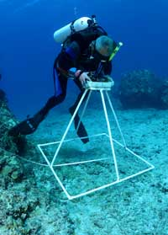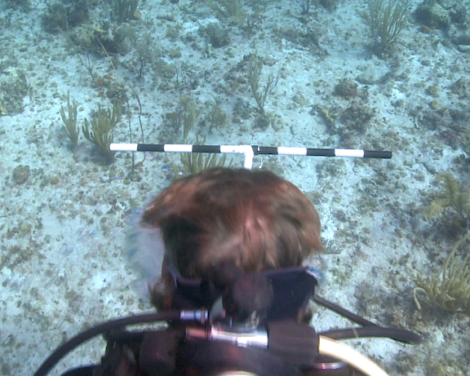

http://www.hawaiianatolls.org/images/smphotos/coral\_survey\_sm.jpg

http://www.sciencewithoutborders.org/fish-spotting/

**Figure 7**. (A) Holding a T-bar while swimming along a transect (B) Taking a photoquadrat

**Activity: Sampling for Abundance - Transects and Quadrats**

Use transects and quadrats to sample an area and determine the abundance of your objects of interest.

**Materials**

**To create study site:**

* Colored cards or other items to represent different categories
* *Optional:* Blankets, boxes, and other materials to create a complex study site

**To sample study site for abundance:**

* Transect
* Quadrat
* Clipboard
* Pencil
* Transect data sheet
* Quadrat data sheet
* Skewer
* *Optional:* Objects representing physical and chemical sensors

**Procedure**

1. Create a study site in your classroom or go to a study site designated by your teacher.
2. Observe the study site and make predictions. Which category do you think is most abundant? Which category is least abundant?
3. Use your predictions to make a hypothesis about the abundance of categories at your study site.
4. As a class, plan how to conduct your data collection accurately and in the span of time allocated by your teacher. You will need to make decisions about:
   1. How to place the transect(s)
   2. How long the transect(s) will be and how far apart transects will be from each other
   3. How frequently you will collect transect point-intercept data
   4. At which transect points you will place your quadrat(s)
   5. How you will place your quadrat in relation to the transect
   6. Whether you will use the squares modification for the quadrat percent-cover method
   7. How you will standardize your categorization of species and substrates
5. If necessary, customize the data sheets to reflect your study site, including transect length and where quadrats will be laid.
6. Collect data following the class procedure. Use a skewer to assist in accurately determining what is directly at a transect point or quadrat intercept.
7. *Optional:* Your group may be given objects representing physical and chemical sensors, which can measure certain parameters. Determine where you should place your sensor(s) to collect data that will allow you to draw useful inferences about the interaction between the biotic and abiotic factors in the environment.
8. Compile class data.
9. Analyze, share and present this data.

Name(s):\_\_\_\_\_\_\_\_\_\_\_\_\_\_\_\_\_\_\_\_\_\_\_\_\_\_\_\_\_\_\_\_\_\_\_\_\_\_\_\_\_\_**\_\_**Date:\_\_\_\_\_\_\_\_\_\_\_\_\_\_

Location: \_\_\_\_\_\_\_\_\_\_\_\_Transect Line #: \_\_\_\_Start time: \_\_\_\_\_\_\_ End Time: \_\_\_\_\_\_\_\_

**Point-intercept Transect**

Record which single “species” (i.e. snail, pencil, colored index card) or “substrate” (i.e. desk, floor, rock) you find directly underneath the transect points.

|  |  |
| --- | --- |
| **Transect**  **Point (m)** | **Organism / Substrate** |
| **0** |  |
| **0.25** |  |
| **0.5** |  |
| **0.75** |  |
| **1** |  |
| **1.25** |  |
| **1.5** |  |
| **1.75** |  |
| **2** |  |
| **2.25** |  |
| **2.5** |  |
| **2.75** |  |
| **3** |  |
| **3.25** |  |
| **3.5** |  |
| **3.75** |  |
| **4** |  |

Name(s):\_\_\_\_\_\_\_\_\_\_\_\_\_\_\_\_\_\_\_\_\_\_\_\_\_\_\_\_\_\_\_\_\_\_\_\_\_\_\_\_\_\_**\_\_**Date:\_\_\_\_\_\_\_\_\_\_\_\_\_\_

Location: \_\_\_\_\_\_\_\_\_\_\_\_Transect Line #: \_\_\_\_Start time: \_\_\_\_\_\_\_ End Time: \_\_\_\_\_\_\_\_

**Quadrats: Point Counts**

Write categories in the first column (e.g. colors of cards). Place your quadrat at the first transect point along the top row. Count what is directly underneath each point where the strings cross. Make a hatch mark for each point in the appropriate column. Each column represents a different quadrat placement. Before moving onto the next transect point, double-check your addition (bottom row) to ensure your quadrat total is correct.

|  |  |  |  |  |  |  |  |  |  |
| --- | --- | --- | --- | --- | --- | --- | --- | --- | --- |
| **Categories** | **Transect Point (m)** | | | | | | **Total Points Across All Quadrats** | **Average Points**  **Per Quadrat** | **Average Percent**  **Per Quadrat (%)** |
| **0** | **1** | **2** | **3** | **4** | **5** |
|  |  |  |  |  |  |  |  |  |  |
|  |  |  |  |  |  |  |  |  |  |
|  |  |  |  |  |  |  |  |  |  |
|  |  |  |  |  |  |  |  |  |  |
|  |  |  |  |  |  |  |  |  |  |
|  |  |  |  |  |  |  |  |  |  |
|  |  |  |  |  |  |  |  |  |  |
|  |  |  |  |  |  |  |  |  |  |
| **Quadrat Total** |  |  |  |  |  |  |  |  |  |

Name(s):\_\_\_\_\_\_\_\_\_\_\_\_\_\_\_\_\_\_\_\_\_\_\_\_\_\_\_\_\_\_\_\_\_\_\_\_\_\_\_\_\_\_**\_\_**Date:\_\_\_\_\_\_\_\_\_\_\_\_\_\_

Location: \_\_\_\_\_\_\_\_\_\_\_\_Transect Line #: \_\_\_\_Start time: \_\_\_\_\_\_\_ End Time: \_\_\_\_\_\_\_\_

**Quadrats: Percent-cover**

Write in categories as above. Estimate how much cover each category represents. Start with the category that takes up the least amount of room. Make sure your percentages add up to 100 in the total column (or the number of square in your quadrat if you are using the squares modification). Double-check your addition (bottom row) before you move your quadrat to the next transect point.

|  |  |  |  |  |  |  |  |  |
| --- | --- | --- | --- | --- | --- | --- | --- | --- |
| **Categories** | **Transect Point (m)** | | | | | | **Total Percent-cover Across All Quadrats (%)** | **Average Percent-cover Per Quadrat (%)** |
| **0** | **1** | **2** | **3** | **4** | **5** |
|  |  |  |  |  |  |  |  |  |
|  |  |  |  |  |  |  |  |  |
|  |  |  |  |  |  |  |  |  |
|  |  |  |  |  |  |  |  |  |
|  |  |  |  |  |  |  |  |  |
|  |  |  |  |  |  |  |  |  |
|  |  |  |  |  |  |  |  |  |
|  |  |  |  |  |  |  |  |  |
| **Quadrat Total** |  |  |  |  |  |  |  |  |

**Activity Questions**

1. Explain why your class chose to use the sampling scheme you determined, including the sensors if you used them.
2. Why was it important to have a class procedure for data collection? What would happen if you did not follow the class procedure?
3. Compare the transect point-intercept, quadrat point-intercept, and quadrat percent-cover data. What are the similarities and differences in category abundance?
4. What are the pros and cons of each sampling method for your study area:
   1. Transect point-intercept
   2. Quadrat point-intercept
   3. Quadrat percent-cover
5. What are potential sources of error for each sampling method?
6. Compare the transect and quadrat data to the actual study site. Do you think the sampling methods accurately sampled this area? Why or why not?
7. What is the importance of the information at the top of the transect data sheet, including start and end times, location, date, and transect line number?
8. If you had to survey the study site again, what would you do differently? Be specific.
9. Different sampling techniques work better in different areas. Think about how you would use transects and/or quadrats to accurately and efficiently sample the following areas to gain the most information about the site:
   1. A crater on Mars
   2. A deep-sea vent
   3. A parking lot