**Table 1.1.** Common algal terms

|  |
| --- |
| **Alga** – single aquatic plant |
| **Algae** – multiple aquatic plants |
| **Blade** – often a large flattened branch (Fig. 1.1) |
| **Calcified** – describes an organism with calcium carbonate in its tissue (often for structure and defense). Calcified algae are often whitish in color with a hard or brittle texture. |
| **Dichotomous** – a branching pattern in which branches are divided in two (Fig 1.2) |
| **Filaments** or **filamentous** – very thin branches, usually chains of connected single cells (Fig 1.2) |
| **Holdfast** – part of the thallus that anchors the plant to the substrate (rock, sand, coral rubble, other organisms) (Fig. 1.1) |
| **Midrib** – a thickened portion in the center of an algal blade or stipe. The midrib may look similar to a vein, however, algae do not have vascular tissue (vascular tissue circulates fluid and nutrients) (Fig. 1.1) |
| **Pneumatocyst** – air bladders used to hold the alga upright in the water. (Fig. 1.1) |
| **Segmented** – an algal thallus that is visibly divided into separate uniform parts or sections (Fig 1.2). |
| **Stipe** – stem-like structure. Unlike terrestrial plants, the stipe does not have vascular tissue. (Fig. 1.1) |
| **Thallus** – main body of the alga. (Fig. 1.1) |

algal morph fig1.1a.tifffig 2.1 part b.003.tiff

**c. d.**

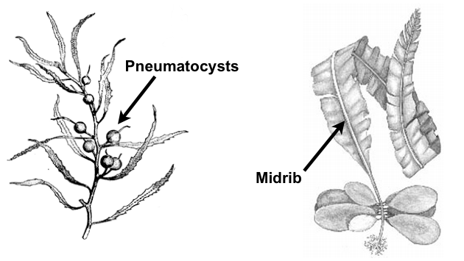

**Fig 1.1.** Diagram showing general algal morphology (a) *Padina* including thallus, blade, stipe, and holdfast. (b) *Dictyosphaeria* showing thallus and holdfast (this algae does not have a stipe or blade) (c) *Sargassum* showing pneumatocycles (d) *Alaria* showing midrib.

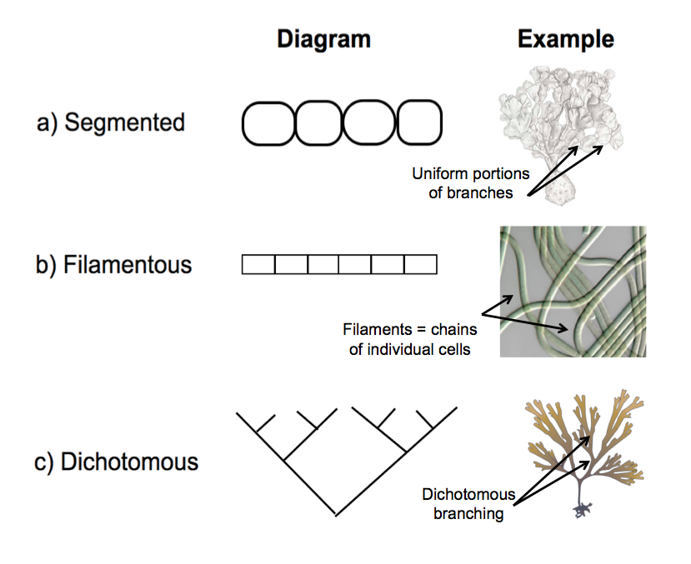

**Fig 1.2.** Diagram demonstrating a) segmented, b) filamentous, and c) dichotomous body plans

**Activity: Algae Identification with Dichotomous Key**

Identify algae genera using a dichotomous key.

**Materials**

* Algae
* Seawater
* Containers for algae
* Dichotomous key to local algal genera
* Additional information about algal species (e.g. books and online resources)
* Petri dishes or microscope slides
* Vinegar
* Plastic pipettes or droppers
* Scissors

**Procedure**

1. Choose an alga to examine.
2. Use the dichotomous key (Table 1.2) to determine the genus of the algal species you have chosen to examine.
   1. Read the *first two lines* of the dichotomous key and choose the most appropriate statement about your alga. Record and proceed to the numbered step given at the end of the line you choose. Note that the first step in the dichotomous key asks whether or not the alga is calcified. Proceed to procedure step 2b if you are unsure whether your alga is calcified, otherwise proceed to procedure step 2c.
   2. Determine if the alga is calcified.
      1. Cut a small piece of the algal thallus, approximately 1cm x 1cm in size, and place in a petri dish or on a microscope slide.
      2. Using a dropper or a pipette apply 3-5 drops of vinegar to the alga.
      3. Bubble formation indicates that calcium carbonate is present. Observe if bubble formation is present.
      4. Decide if your alga is calcified.
   3. Proceed to the next set of two steps in the dichotomous key indicated from procedure step 2a. Choose the most appropriate statement about your alga. Continue following the dichotomous key and recording your process as you work until you reach an algal genus*.* If you are unsure of a particular step, mark that step, and then use your best judgment to proceed.
3. Once you have determined an algal genus, refer to additional resources and compare your identification with the available information.
   1. If the identification does not seem reasonable, go back to the recorded steps you made when using the dichotomous key. Consider any steps you were unsure about and try again.
   2. Repeat Steps 2-3 of the procedure.
4. If there is time, repeat Steps 1-3 for additional algae.

**Activity Questions:**

1. What are the advantages and disadvantages using a dichotomous key to identify species?
2. You validated your algae identification from the dichotomous key by comparing your identification to other available resources. How accurate were your identifications? If you felt your identification was not accurate, explain why and what steps you took to correct your identification.
3. How did your actions using the dichotomous key reflect those of a professional scientist?
4. Why is it important to identify organisms?

**Table 1.2.** Dichotomouskey to common genera of Hawaiian intertidal and subtidal algae. Definitions of bolded words can be found in Table 1.2. Diagrams of algal morphology can be found in Figs 1.1-1.2.

|  |
| --- |
| 1. **Thallus** is **calcified** and may be hard in texture, have white bands, or form bubbles in  presence of vinegar …………………………………………………………………………………..…...……(2) |
| 1. **Thallus** is not **calcified**…………………………………………………………………………………………(5) |
| 2. **Thallus** forms a thin hard crust on rock or coral rubble………………………...(*Crustose Coralline Algae*) |
| 2. **Thallus** does not form a thin hard crust on rock or coral rubble…………………………………...………(3) |
| 3. Blades are fan shaped with visible bands of **calcium carbonate**…………………………………..(*Padina)* |
| 3. Blades are not fan shaped…………………………………………………………………………...……….. (4) |
| 4. Branches are **segmented**. Each segment is flattened………………………………………..…(*Halimeda*) |
| 4. Branches are **dichotomous** without segments and cylindrical in shape………….(*Liagora or Galaxaura*) |
| 5. **Thallus** is **dichotomously** branched…………………………………………………………..…………….(6) |
| 5. **Thallus** not **dichotomously** branched…………………………………………………………………..…..(7) |
| 6. Branches or blades have a thickened **midrib**……………………………………………………(*Dictyopteris*) |
| 6. Branches and blades do not have a thickened **midrib**…………………………………………......(*Dictyota*) |
| 7. **Thallus** contains many small **pneumatocysts**……………………………………………......(*Sargassum*) |
| 7. **Thallus** does not have **pneumatocysts**.……………………………………………………………...……..(8) |
| 8. **Thallus** has many cylindrical or **filamentous** branches………………………….…………...……………(9) |
| 8. **Thallus** is not made up of cylindrical or **filamentous** branches………………………………………..(14) |
| 9. Branches are thin and **filamentous**………………..………………………………………………..…….(10) |
| 9. Branches are thick or have many small thin **filaments** in whorls around main branch………………(11) |
| 10. Algae has many thin smooth **filaments** often forming tufts………..……………………..…..(*Cladophora*) |
| 10. Branches are thin and cylindrical, often having small hooks on the end of the branch………...(*Hypnea*) |
| 11. Branches have many small **filaments** in whorls, giving alga a furry appearance underwater……..…………………………………………………………………………………... (*Wrangelia*) |
| 11. Branches lack small filaments……….……………..……………………………………………………….(12) |
| 12. Branches have tiny spine-like or bulb protrusions………….…………………………....…………….…(13) |
| 12. Branches lack spine-like or bulb protrusions……….………………..………………...……….(*Gracilaria*) |
| 13. Branches have tiny spine-like protrusions…………………………………..……………..(*Acanthophora*) |
| 13. Branches have tiny bulb protrusions……………………………...…………………..………...(*Laurencia*) |
| 14. **Thallus** forms a spongy fan shape……………………………………...…………………...(*Avarainvillea*) |
| 14. **Thallus** is not fan shaped…………………………………………………...………………………………(15) |
| 15. **Thallus** has cone or cup shaped branches with spike-like protrusions…………………..…. (*Turbinaria*) |
| 15. **Thallus** lacks spike like protrusions……..……………………………………………………………….. (16) |
| 16. **Thallus** forms a netlike mesh of **filaments**. The **thallus** is somewhat crunchy to the touch….…………………....……………………………………………………………………. (*Microdictyon*) |
| 16. **Thallus** forms blade like folds, occasionally forming hollow cup shape. The **thallus** is firm to the touch…………………….……………………………………………………………………(*Dicytosphaeria*) |

**Activity: Making Algae Presses**

Construct algal presses to preserve algae.

**Materials**

* Algae
* Seawater
* Containers for algae
* Heavy paper (card stock, herbarium paper, or half of file folder)
* Wax paper
* Towels
* Blotters such as newspaper, towels, fabric
* Pair of cardboard backings cut to at least 8.5 x 11 inch
* Weights such as books or bricks
* Craft glue (if needed)
* Fan (optional)

**Procedure**

1. Choose an alga that you have identified and rinse any sediment off with seawater.
2. Pat alga dry with a towel.
3. Write your name and the genera or species name in pencil on the heavy paper so that the algae can be identified after pressing.
4. Position the alga on your heavy paper so that it is centered. Spread out the thallus, branches, and blades. Be sure to position the alga so that any unique characteristics are visible. If the alga is a large thick clump, you may need to cut the alga in half so it will lay flat, or you may need to choose a smaller piece.
5. Build your algae press (Fig 1.3). If you are pressing a single alga follow steps a-f. If you are pressing several algae on several sheets then repeat steps a-f as many times as needed.
   1. Place a piece of cardboard down on the table.
   2. Put a blotter (newspaper, towel, fabric) on top of the cardboard. Blotters will help remove moisture from the alga in your press.
   3. Put your paper with algae positioned on top of it on top of the blotter.
   4. Carefully cover the algae with a sheet of wax paper.
   5. Add a second blotter to the top of the wax paper.
   6. Place a second piece of cardboard on top of the second blotter.

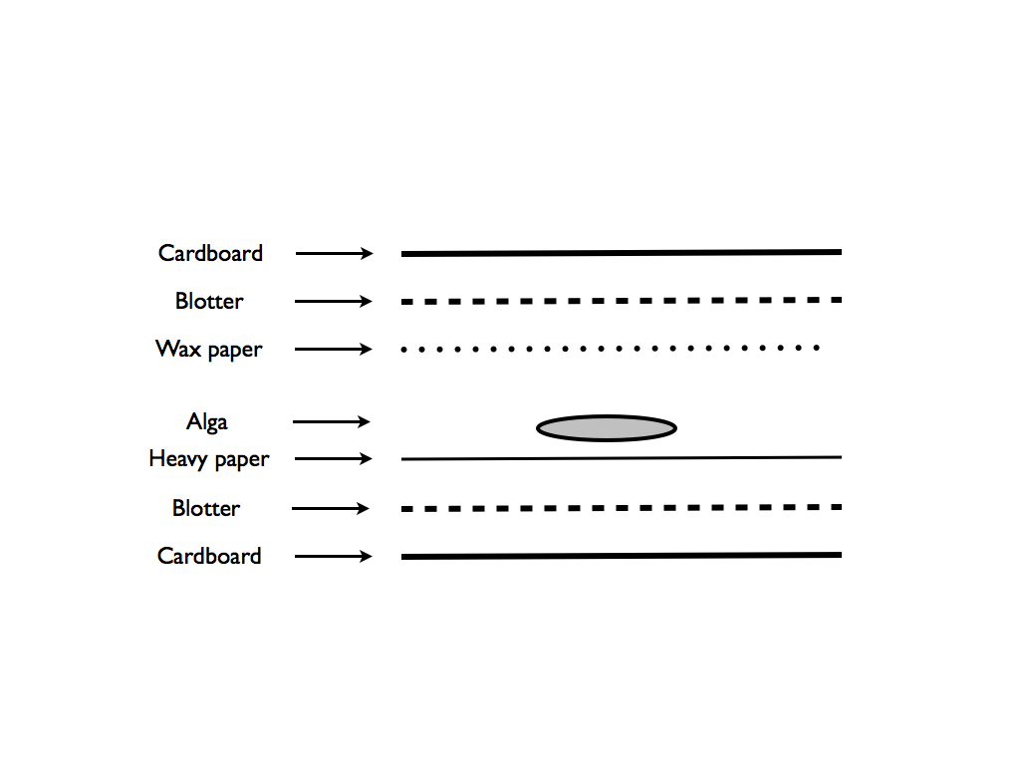

**Fig 1.3.** Diagram of algal press layers

1. Place heavy weights on top of your algae press so that the weight is evenly distributed on the cardboard above your alga.
2. Dry algal presses. Drying may take up to a week for thick algae. Blowing a fan at the press will make the presses dry more quickly. Throughout the drying process, wet blotters may need to be swapped with dry blotters, especially if the alga is large.
3. Once dried, carefully remove the wax paper from the alga, leaving the alga pressed to the paper behind. If needed, a small amount of glue can be used to secure the alga to the paper.
4. (Optional) Identify and label any important features of the algae you pressed on the heavy paper.

**Activity Questions:**

1. Why is it important to preserve specimens?

2. If you made several algal presses, was there an alga that was more difficult to manipulate and press? How would you change your pressing technique to address those difficulties