**TSI Lesson Reflection – TSI Phase Diagram**

Name: ___B.Silver_________________________________

Activity: ___Density Bags________________________________

What level did you observe? 🞎 Individual 🞎 Pair X Small group 🞎 Full Class

Why did you observe this level? The class is set up in small learning groups for experiments and learning experiences.

Draw arrows indicating your progression through the TSI Phases of Inquiry. Number your arrows.

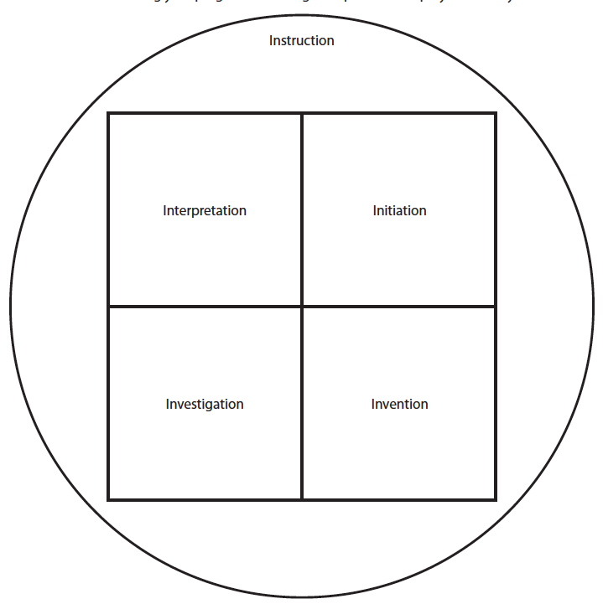

9

8

7

6

5

4

3

2

1

Review of soda experiment