Dan VanRavenswaay

TSI Inquiry Phase Diagram

for Practices of Science lesson

October 2012

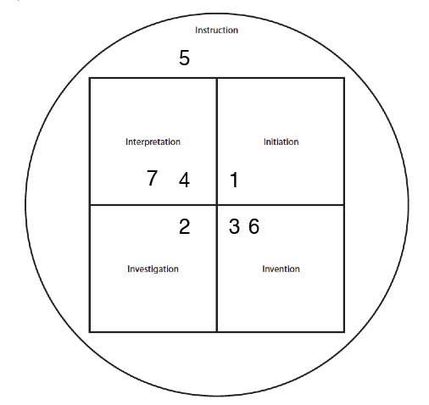

1. Ask question “What do you think a scientist looks like?”

2. Draw a picture of a scientist

3. Ask why students drew what they drew.

4. Students talk with each other in pairs about what they drew.

5. Discuss what these ideas (and stereotypes) as a class.

6. Make a list of what scientists do when they’re doing science.

7. Consolidate student lists into a class list.